Back to School Scavenger Hunt!

Welcome Natchez Families! Please follow the directions in each of the squares. Each time you complete an activity, have a Natchez staff member stamp the box for you. When you have an initial in each of the squares, turn your card in to Elisha from Communities in schools to receive a treat and a drink to take with you!

Thank you for joining us!!
School Wide PBIS presentation | Show your family your classroom. | Say Hello to Mr. Kirk
Spot the nurses office.   | Say hi to one friend   | Go to the music room.
Say Hi to Ms. Larson In the library. | Introduce your family to Ms. Tuttle the new counselor. | Turn in for a treat to Elisha from  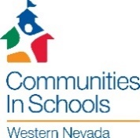

Please join us for
Back to School night at Natchez

Tuesday, August 27th, 2019
5:30 – 6:30 PM

We will meet in the multipurpose room for a short whole school presentation to discuss the schoolwide PBS system, attendance policy, and other important information.

From there visit your child’s classroom and other stops to complete a scavenger hunt, that you will turn in for a back to school treat.

We look forward to seeing you!

